Snap Teams Up with NBCUniversal, Duplass Brothers on Original Content
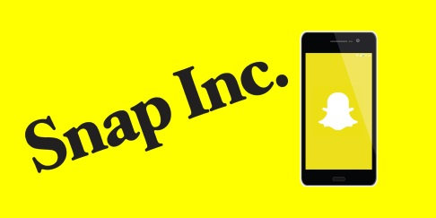
Snap and NBCUniversal have created a joint studio to produce original content, including scripted shows. Snap has also signed a deal with the Duplass Brothers' creative agency, Donut, to produce original content for brands.
Adweek 10/16/17
http://www.adweek.com/tv-video/snapchat-and-nbcuniversal-are-creating-a-digital-content-studio-for-scripted-shows/

