Announcing the U.S. Social Media Communications Awards 2020
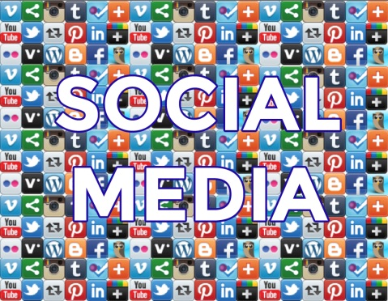
The U.S. Social Media Communications Awards celebrate the best in U.S. social media communications and reward the individuals, companies, and organizations who are using online platforms to communicate in fresh and innovative ways.
Search Engine Journal 10.21.19
https://www.searchenginejournal.com/us-social-media-communications-awards-2020/330667/?utm_source=email&utm_medium=daily-newsletter&utm_campaign=daily-newsletter#close
Image credit:
https://ossiningufsd.org/assets/site/social-media-collage.jpg

