Social media "Has Never Been More Important"
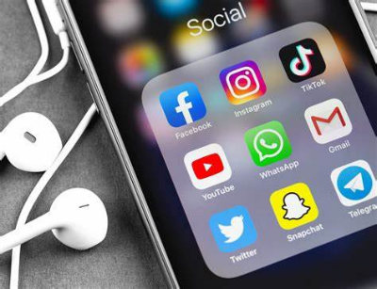
Social media is used by 62.3% of the world's population, up 5.6% over 2023, with users averaging 2 hours and 23 minutes daily on platforms and replacing WhatsApp as their "favorite" in favor of Instagram. We Are Social co-founder Nathan McDonald says the rise of TikTok is an indication that "social is not somewhere where a broadcast approach works for brands, and the importance of thinking social first has never been more important."
Marketing Tech (UK) 2/28/24
https://www.marketingtechnews.net/news/2024/feb/28/global-social-media-users-pass-5-billion-milestone/
Image copyright:
https://www.webtms.com/wp-content/uploads/2020/08/Social-media-v2-scaled.jpg

