Social Media, Smartphone Use Up Among Older Generations
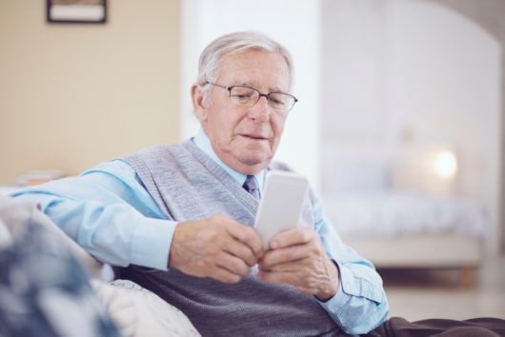
Facebook usage by baby boomers and consumers ages 74 and older has risen by double digits in the last four years, and smartphone use by baby boomers has increased from 25% to 68% since 2011, the Pew Research Center reports. The study also found that social media use among millennials has stayed steady since 2012 but, for those age 39 and older, has risen by a minimum of 10 percentage points.
MediaPost Communications 9/9/19
https://www.mediapost.com/publications/article/340465/older-consumers-embrace-new-media-tech-in-big-way.html

