Social Media Will Hit Major Milestones in 2018
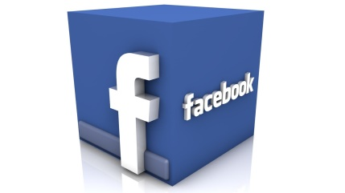
Facebook’s growing dominance of digital is already well-known; this year it will account for 23.0% total US digital ad spending. But it will also hit a new height in 2018, taking in $1 of every $10 spent on all advertising—digital and nondigital combined.
eMarketer 1.9.18
https://www.emarketer.com/content/social-media-will-hit-major-milestones-in-both-ad-revenues-and-usage-in-2018?ecid=NL1001

