Some Media Companies Cool on YouTube Distribution
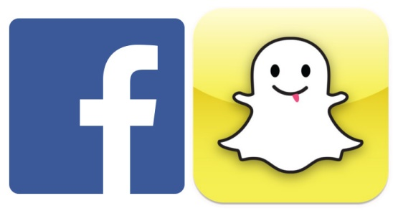
“You never count Google out, but something has to change at YouTube, or Facebook and Snapchat are going to own this world,” said a prominent digital media executive. For some newer media companies, YouTube has become an afterthought, this person said. “Google can’t rest on its laurels.”
The Wall Street Journal 7.21.16
http://www.wsj.com/article_email/some-media-companies-cool-on-youtube-distribution-1469095200-lMyQjAxMTE2NDI1MTIyOTE3Wj?utm_source=API+Need+to+Know+newsletter&utm_campaign=ad0a853d76-Need_to_Know_July_22_20167_22_2016&utm_medium=email&utm_term=0_e3bf78af04-ad0a853d76-31697553

