Sonic Branding Could Be Missed Marketing Opportunity
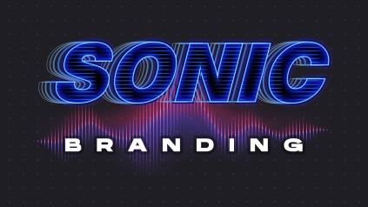
Research indicates sonic branding within podcast and other audio ads can boost recall and purchase intent by double-digit percentages, but the tactic is one of the least understood trends among agency executives. To reap the greatest rewards, audio researcher Veritonic says marketers should craft a memorable melody, integrate the brand name with the audio logo and integrate the sonic identity across all media efforts and channels.
Inside Radio 2/24/23
https://www.insideradio.com/free/report-sonic-branding-not-fully-understood-by-media-agencies/article_333ff768-b420-11ed-be3d-2f7acc6ab10b.html
Image credit:
https://i.ytimg.com/vi/3AIwPbwtNZ0/maxresdefault.jpg

