Made Music Creates A Sonic Logo For Tostitos
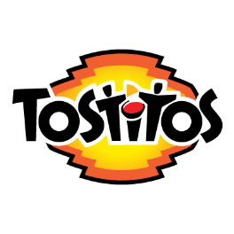
Tostitos teamed with Made Music Studios to create the brand's first sonic logo, which features the sound of a crunch accompanied by drumbeats on the brand's salsa jar lids. The logo can be heard at the end of a six-second spot from Goodby Silverstein & Partners, and Made Music's John Taite says the sonic logo serves as "a fast memory trigger to stand out in a crowded market, designed to complement the brand's visuals."
Muse by Clio 3/14/22
https://musebycl.io/music/tostitos-goes-beyond-crunch-its-first-sonic-logo

