Sony’s Mobile Game Acquisition Is An Opportunity For In-Game Ads
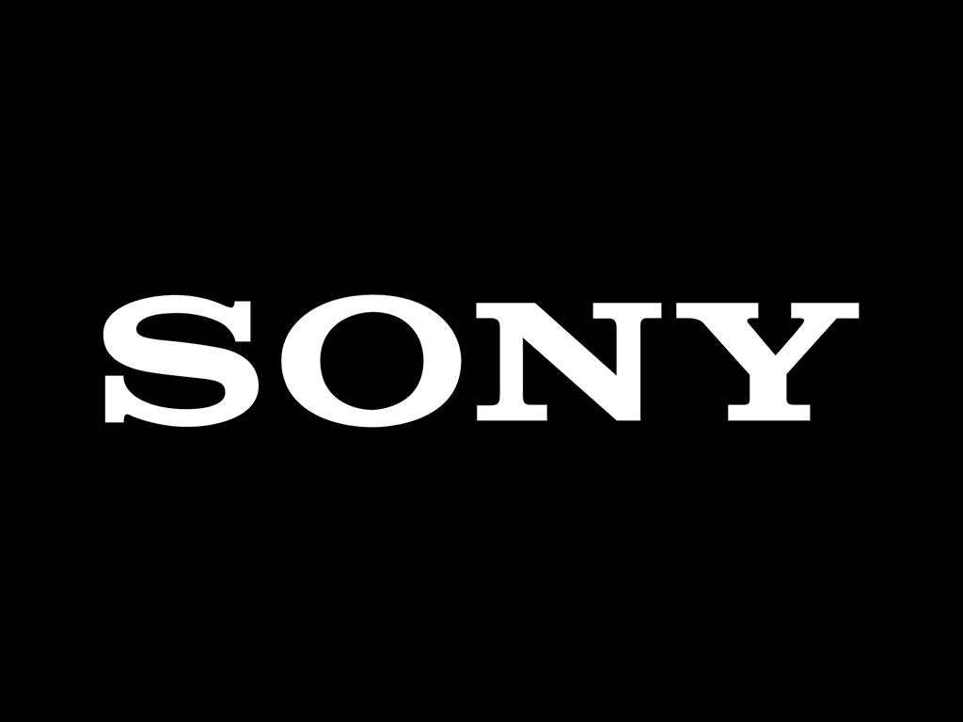
Sony has acquired European mobile game developer Savage Games, expanding its presence beyond gaming consoles to mobile devices. the studio’s leaders come from prestigious, successful studios like Rockstar (creators of “Grand Theft Auto”). The company’s first game will reportedly be a live service mobile shooting game—a lucrative genre that’s made way for some of the highest-grossing games in recent memory.
eMarketer 8.30.22
https://www.insiderintelligence.com/content/sony-s-mobile-game-acquisition-opportunity-in-game-ads?ecid=NL1001&utm_campaign=eDaily+8.31.2022&utm_medium=email&utm_source=Triggermail&utm_term=eMarketer+Daily+CORE%2fEMEA+(Mon-Fri)

