South Dakota's Drug Awareness Campaign Goes Viral
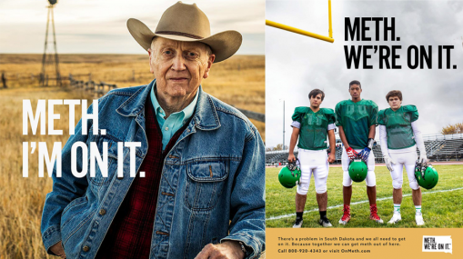
Broadhead's drug awareness campaign for South Dakota has gone viral due to its "Meth. We're on it." slogan and dedicated site, onmeth.com. Twitter users expressed confusion, and some derision, about whether the campaign was actually advertising drug use but Governor Kristi L. Noem has so far praised the work for getting people talking about the issue.
The Drum (free registration) 11/18/19
https://www.thedrum.com/news/2019/11/18/south-dakota-s-we-re-it-anti-meth-campaign-puzzles-the-twitterverse
Image credit:
https://images.foxtv.com/static.fox5dc.com/www.fox5dc.com/content/uploads/2019/11/932/524/Meth.-were-on-it.png?ve=1&tl=1

