Spanish-Language Titans Announce Merger
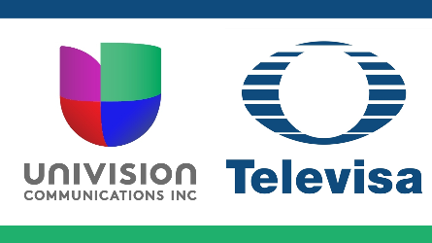
Grupo Televisa and Univision Communications announced the formation of Televisa-Univision, the biggest company in the world to provide media in Spanish. The united corporation, which a Televisa executive expects to bring in roughly $4 billion of revenue each year, focuses on streaming but also includes cable and broadcast television as well as radio.
Radio Ink 4.14.21
https://radioink.com/2021/04/14/58-univision-radio-stations-part-of-televisa-merger/

