T-Mobile, Comcast Take Up to 75% of Spectrum
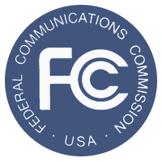
T-Mobile and Comcast were the big spenders during the Federal Communications Commission's broadcast spectrum auction, snatching up as much as 75% of the spectrum, estimates UBS analyst John Hodulik. It is estimated that T-Mobile will be paying up to $10 billion for 30 MHz, while Comcast will be spending up to $6 billion for 20 MHz.
RBR.com 4/2/17
https://rbr.com/t-mobile-comcast-spectrum-auction-spenders/

