Sports Leagues Ask For Instant Piracy Crackdown
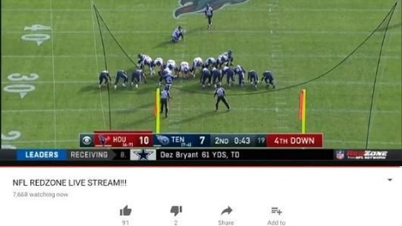
The NBA, NFL and Ultimate Fighting Championship leagues are urging US authorities to require internet service providers to immediately take down pirated livestreams of sporting events and block websites that host pirated content. The leagues argue that the current 1998 Digital Millennium Copyright Act does not clearly define the term "expeditiously," allowing service providers to delay responding to takedown requests.
Ars Technica 8/29/23
https://arstechnica.com/tech-policy/2023/08/sports-leagues-ask-us-for-instantaneous-dmca-takedowns-and-website-blocking/
Image credit:
https://i.pinimg.com/originals/b1/9a/64/b19a6488375380c44d60c7573eb415a1.jpg

