Sports, Bundles Help Slow Cable Subscription Losses
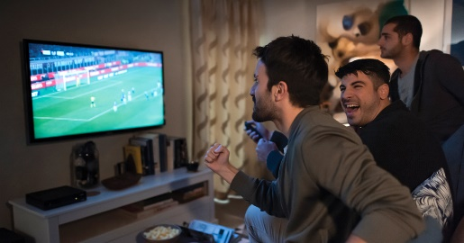
Subscription losses for cable television and pay TV operators are expected to slow in the coming years as the perception of bundle value increases amid rising prices for streaming services, experts predict. Major sports organizations continue to maintain a presence on pay TV platforms as they explore the streaming space, a factor which could also help slow cord-cutting trends.
Next TV/Broadcasting+Cable 12.20.21
https://www.nexttv.com/features/are-cables-video-losses-getting-better
Image credit:
https://www.melita.com/wp-content/uploads/2019/09/fb-og-image.jpg

