DOJ blesses T-Mobile Merger But States Still Balk
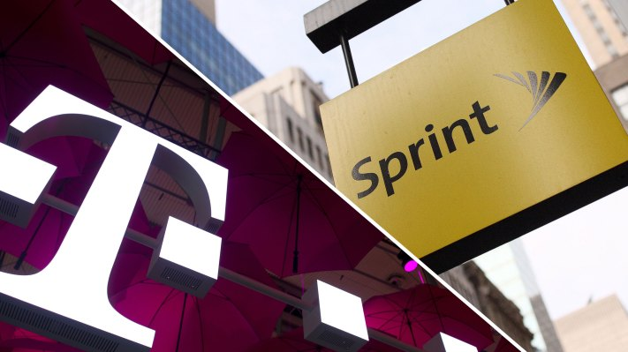
The Justice Department's approval of T-Mobile's proposed $26 billion merger with Sprint still needs to clear one more hurdle: 13 state attorneys general show no signs of abandoning their federal antitrust suit to block the deal. The DOJ's move, in which DISH Network will purchase $5 billion in wireless assets from the carriers, met with mixed reactions and some skepticism that DISH could meet its mandated targets for launching 5G service.
FierceWireless 7/26/19
https://www.fiercewireless.com/wireless/dish-crafts-its-plans-to-become-4th-us-wireless-carrier
Image credit:
http://cthomenavigator.com/wp-content/uploads/2019/07/t-mobile-and-sprint-get-doj-approval-for-26-billion-merger-deal.jpg

