Unique Esports Degree Partnership Announced with Camden County College
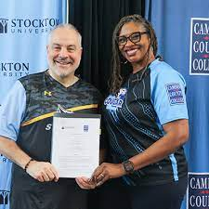
Stockton University became the first public institution in New Jersey to offer an undergraduate degree in esports when the Bachelor of Science in Esports Management program debuted this fall. Camden County College’s Associate in Applied Science in Esports Production degree is the only one of its kind in the region. Now the two programs have joined to create the first esports degree pathway program in the state.
Stockton University 11.2.23
https://stockton.edu/news/2023/camden-county-esports-agreement.html
Image credit:
https://www.google.com/url?sa=i&url=https%3A%2F%2Fwww.camdencc.edu%2Fnews%2Fstockton-university-camden-county-college-announce-unique-esports-degree-partnership%2F&psig=AOvVaw0HHXcAlhquOKMyssHgDIUv&ust=1699550263028000&source=images&cd=vfe&opi=89978449&ved=0CBEQjRxqFwoTCIiMyqD0tIIDFQAAAAAdAAAAABAD

