Streaming, Cable Have Nearly Equal Presence in Homes
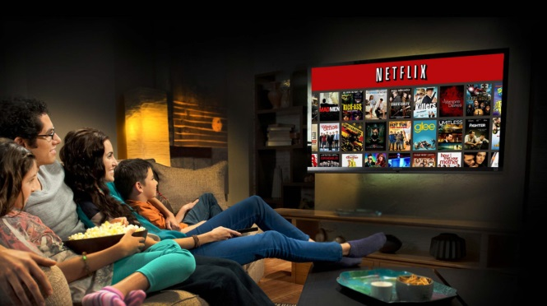
Streaming services have gained comparable market reach as cable providers, Clearleap is reporting. Some 78.5% of people are cable customers, compared with 71.4% who have or previously had a streaming service, research conducted in July indicates. About four in 10 people who use a streaming service are interested in paying $10-$25 each month for a service that would provide a bigger range of content than is available on Netflix, Hulu or Amazon.
Multichannel News 11/16/15
http://www.multichannel.com/news/content/study-streaming-penetration-par-cable/395332

