Survey: Average US Bundled Service Bill Reaches $124
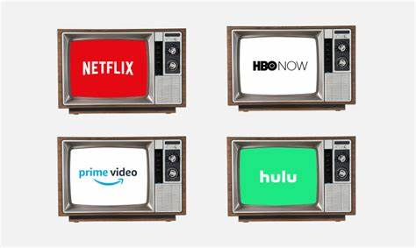
Consumers with bundled video and broadband packages spent an average of $124 a month in the fourth quarter, an 11% rise over six months, TiVo reports. "Cord revivers" made up 26% of survey respondents.
Next TV 4/25/22
https://www.nexttv.com/news/tivo-the-average-us-pay-tv-customer-is-paying-dollar204-a-month-for-broadband-video-entertainment?utm_source=SmartBrief&utm_medium=email&utm_campaign=3E572E13-3FBC-11D5-AD13-000244141872&utm_content=02438A40-5A53-4DEA-A44D-C30D728A649A&utm_term=a25693a1-51b6-4112-bde4-56bd420e983f
image credit:
https://media-cldnry.s-nbcnews.com/image/upload/t_fit-760w,f_auto,q_auto:best/newscms/2019_03/2717531/190115-streaming-services-cable-main-kh.jpg

