Streaming Made Up 25% of TV Minutes in Q2
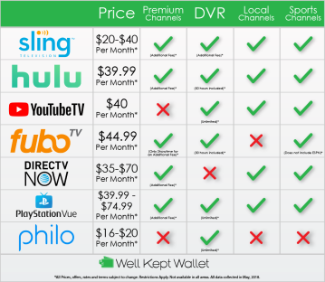
Nielsen reports that streaming accounted for a fourth of all television viewing time in the quarter ending June 30, and that 25% of users are subscribing to more video services. Those working from home due to the pandemic were more apt to watch digital rather than live or time-shifted TV.
Next TV 8.12.20
https://www.nexttv.com/news/nielsen-streaming-grows-to-25-of-tv-usage-in-2q
Image credit:
https://wellkeptwallet.com/wp-content/uploads/Streaming-services-infographic-01.png

