Streaming of NFL Games On the Rise
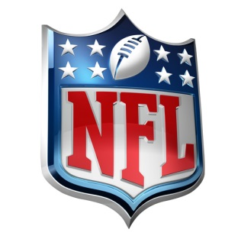
The National Football League reports that game streaming is up 65% compared with a year ago, suggesting that a younger, more digitally savvy audience may be tuning in. The league appears to be committed to digital viewership, even though television remains the most popular way to watch a game.
MediaPost Communications 10/9/18
https://www.mediapost.com/publications/article/326272/streaming-is-way-up-for-nfl-this-season.html

