Streaming Trend Puts Linear TV On The Chopping Block
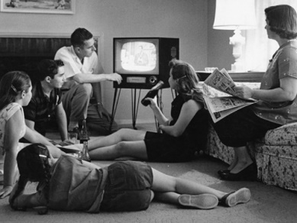
NBCUniversal announced plans to sunset the NBC Sports Network and shift its content to its Peacock streaming service -- a move insiders say will be followed by other media giants as streaming continues to gain ground with audiences. Small cable sports networks may be the next casualties of this shift, Alex Weprin writes.
The Hollywood Reporter 4.28.21
https://www.hollywoodreporter.com/news/cable-tv-channels-shutter-streaming
Image credit:
https://quizpug.com/wp-content/uploads/qc-images/54cadfb70fba2.jpg

