Strong TV Upfront Market Expected this Year
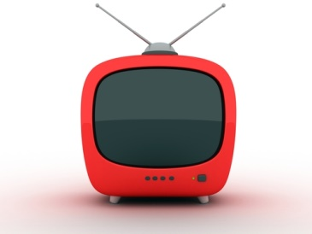
The robustness of TV's scatter market will result in a stronger upfront market as advertisers seek to avoid the same hiked prices next year, observers say. One buyer estimated that TV networks would increase CPM by 5% to 9%. "For those seeking broad reach, sight-sound-and-motion and brand awareness traditional TV still utterly dominates all alternatives despite the growth of digital media owners and increasing consumption of video on Internet-connected devices," said Pivotal Research Group's Brian Wieser.
Variety 3/14/16
http://variety.com/2016/tv/news/2016-tv-upfront-tv-networks-ad-rates-tv-advertising-1201729219/

