Student Reporter Sues University President for Forbidding Journalism
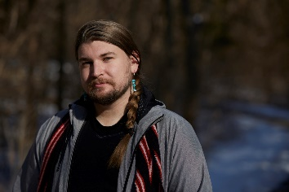
Jared Nally wants Haskell Indian Nations University, a public institution operated by the federal government, to answer for the 90 days he was silenced, without any due process, under a directive that banned him from engaging in basic acts of journalism. He also wants Haskell to restore over $10,000 of funding that the university inexplicably shorted the newspaper, approve its registration as a student organization, and revise the unconstitutional policy on campus speech used to issue the directive.
FIRE 3.2.21
https://www.thefire.org/lawsuit-student-reporter-sues-university-president-for-forbidding-journalism/
Image credit:
https://www.bing.com/images/search?view=detailV2&ccid=ldTZmhzP&id=8627AC6F55F1437ACAB857EFC99B169F93AF58D2&thid=OIF.qtjv4QeU6WRmf8Jzf8bI4A&mediaurl=https%3a%2f%2fogden_images.s3.amazonaws.com%2fwww.ljworld.com%2fimages%2f2021%2f03%2f02101326%2fJared_Nally_WS_5.jpg&exph=800&expw=1200&q=Jared+Nally+&simid=87389899554&ck=AAD8EFE10794E964667FC2737FC6C8E0&selectedIndex=1&FORM=IRPRST&ajaxhist=0

