Studio Musicians Demand A Cut of Streaming Residuals
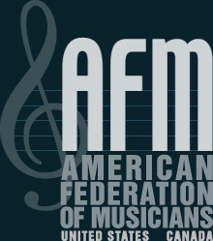
Instrumental musicians at television and movie studios are sounding an alarm over their inability to earn a living after being denied a share of streaming residuals as a growing number of media giants embrace on-demand platforms. The Alliance of Motion Picture and Television Producers is in talks with the American Federation of Musicians, which notes that residuals make up around 75% of the average studio musician's income.
The Hollywood Reporter 10/10/19
https://www.hollywoodreporter.com/news/is-an-extinction-level-event-musicians-fear-livelihood-streaming-residuals-1246824

