Super Bowl 50 Gets 49.0 rating, Ad Meter Voters Pick Top Commercials
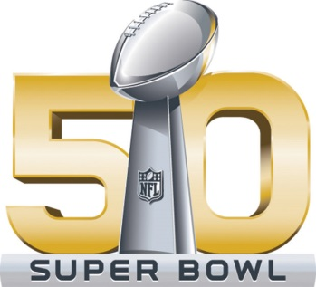
Sunday night's Super Bowl 50 received a 49.0 market rating and 73 share, the second-highest for the event since metered ratings began in 1976. Separately, USA Ad Meter voters picked the top five Super Bowl commercials, with Hyundai's "First Date" receiving a score of 6.91. Other top ad spots included Heinz's "Wiener Stampede," Doritos' "Ultrasound" and "Doritos Dogs," and Hyundai's "Ryanville."
USA Today 2/8/16
http://admeter.usatoday.com/2016/02/07/the-5-best-super-bowl-50-commercials-according-to-ad-meter-voters/

