Nickelodeon Super Bowl Ad Spots Sold Out
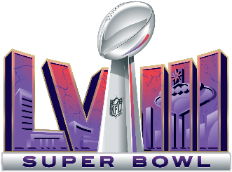
Nickelodeon has sold all its advertising slots for the 2024 Super Bowl, Paramount Global reports. While most ads will also run on CBS and Paramount+, Nickelodeon will air 15 exclusively, each of which could cost from $200,000 to $300,000.
Variety 1.29.24
https://variety.com/2024/tv/news/nickelodeon-super-bowl-commercials-sold-out-paramount-1235890038/
Image copyright:
https://upload.wikimedia.org/wikipedia/en/thumb/d/d7/Super_Bowl_LVIII_logo.svg/1200px-Super_Bowl_LVIII_logo.svg.png

