Super Bowl Draws Fourth-Biggest TV Crowd Ever
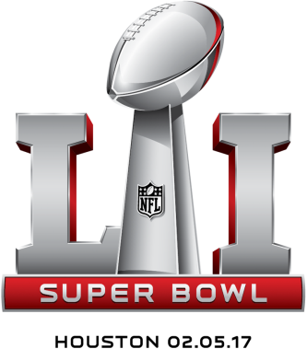
It wasn’t a record. But this year’s Super Bowl viewership ranks among the best ever. Sunday’s game on Fox scored 111.3 million, according to Nielsen, tying the 2012 contest as the fourth-most-watched game in history.
MediaLife 2.7.17
http://www.medialifemagazine.com/early-numbers-third-best-super-bowl-rating-ever/

