Super Bowl Halftime Show Prompts 1,300 + FCC Complaints
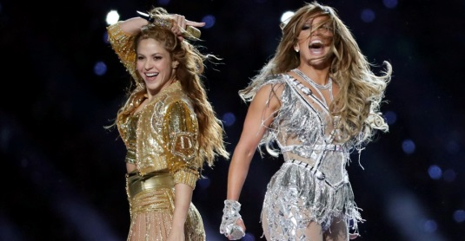
One critic from Illinois, who lodged a complaint the morning after the Feb. 2 game, was appalled that the “disgusting and offensive” performance was aired while minors were watching. “How can they put this on when children are watching? It was like a porno show,” the complaint read.
New York Post 2.26.20
https://nypost.com/2020/02/26/super-bowl-halftime-show-prompts-more-than-1300-fcc-complaints-like-a-porno-show/?utm_source=Listrak&utm_medium=Email&utm_term=Here%26%23039%3bs+How+Many+People+Complained+To+FCC+About+%26%23039%3bPorno%26%23039%3b+Super+Bowl+Halftime+Show&utm_campaign=4Q+Earnings%3a+Gray+Up%2c+Graham+Down
Image credit:
https://cdn.theatlantic.com/assets/media/img/mt/2020/02/RTS30LFI/facebook.jpg?1580733385

