Super Bowl Streaming Audience Lowest Since 2016 at 1.4M Viewers
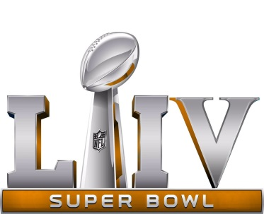
According to our fancy math, Super Bowl LIV yielded a streaming audience of under 1.4 million viewers, the lowest total since 2016 and off significantly from the 2.6 million concurrent streams measured by Nielsen for 2019’s game, broadcasted by CBS and featuring the New England Patriots beating the Los Angeles Rams.
NextTV 2.3.20
https://www.nexttv.com/news/super-bowl-streaming-audience-lowest-since-2016-at-14m-viewers?utm_source=Listrak&utm_medium=Email&utm_term=Super+Bowl+Streaming+Audience+Lowest+Since+%26%23039%3b16&utm_campaign=Black+Dragon+Capital+Buys+Grass+Valley
Image credit:
https://pbs.twimg.com/media/C4R2ZTzUcAAnvop.jpg:large

