Survey Finds Gaming Beats Streaming In Money Spent
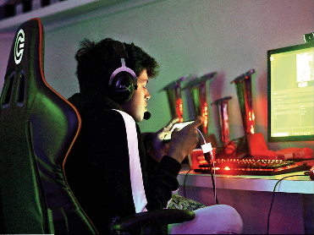
Gamers spend a yearly average of $912 on the hobby, a Pollfish survey found, while the typical American spends roughly $564 for streaming services during the same period. The category accounted for internet access as well as games, equipment and in-app transactions.
MediaPost Communications (free registration) 6.2.22
https://www.mediapost.com/publications/article/374407/americans-spend-more-on-gaming-than-streaming-o.html
Image credit:

