SVOD Services' Output Soared Globally In 2022
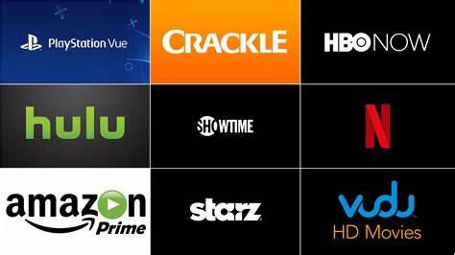
Subscription streaming services generated 60% more titles and 87% more hours of content in 2022 than 2021, Omdia reports, and 42% came from productions operating on continents other than North America. The company credits returns to production following shutdowns related to COVID-19 and the expansion of streaming services worldwide.
Telecompetitor 3/14/23
https://www.telecompetitor.com/trend-report-streaming-services-are-generating-a-lot-more-content/
Image credit:
https://www.bing.com/images/search?view=detailV2&ccid=zq4R95lj&id=38A9E60708BA51BD4BDCA21DBD94ED81584F9FA1&thid=OIP.zq4R95lj2SS0Qk3SFEp4cwHaEK&mediaurl=https%3a%2f%2fimg4.looper.com%2fimg%2fuploads%2f2017%2f02%2fstreaming.jpg&cdnurl=https%3a%2f%2fth.bing.com%2fth%2fid%2fR.ceae11f79963d924b4424dd2144a7873%3frik%3doZ9PWIHtlL0dog%26pid%3dImgRaw%26r%3d0&exph=2025&expw=3600&q=Subscription+streaming+services+&simid=608052719890083785&FORM=IRPRST&ck=ADCB038BDFC38B91CBE0FEFAC49BC6E7&selectedIndex=99&ajaxhist=0&ajaxserp=0

