U.S. SVOD Spending Grew By Over 17% in 2022, Passed $30 Billion
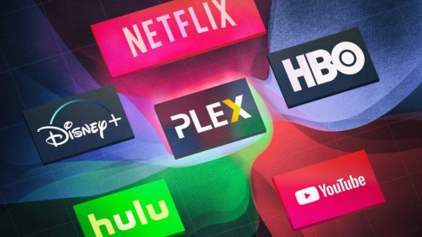
The Great Streaming Recession is just not a thing. U.S. consumer spending on subscription streaming jumped 17.3% in 2022, surpassing $30.3 billion. This latest year-over-year growth, reported by the Digital Entertainment Group (DEG), comes after domestic SVOD spending expanded by nearly 20% in 2021 and 37% in 2020.
Next TV 2.7.23
https://www.nexttv.com/news/the-great-streaming-recession-just-isnt-happening-us-svod-spending-grew-by-over-17-in-2022-passed-dollar30-billion?utm_term=A25693A1-51B6-4112-BDE4-56BD420E983F&utm_campaign=C74FC4FA-5D4D-4151-8915-3043BA411DBE&utm_medium=email&utm_content=737046A9-4487-4A00-BCE0-764A6F03A524&utm_source=SmartBrief
Image credit:
https://www.wipremiertrivia.com/wp-content/uploads/2020/02/Streaming-Channels-1024x576.jpg

