Taco Bell to Release 2 YouTube Series
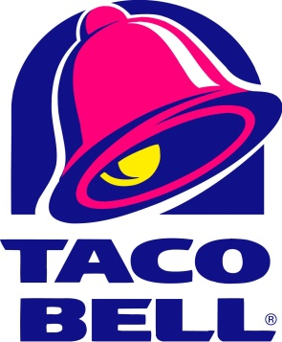
Taco Bell is working on a YouTube campaign that will produce two episodic series for YouTube next year and invite customers to submit their own content. A series called "Taco Tales" will share stories of unexpected events that happen in Taco Bell stores, and a second series called "Taco Bell Clips Show" will feature comedy sketches inspired by fan content.
The Drum (Glasgow, Scotland) 12/8/16
http://www.thedrum.com/news/2016/12/08/taco-bell-flexes-its-social-muscles-youtube

