Tactics to Optimize Integrated Marketing
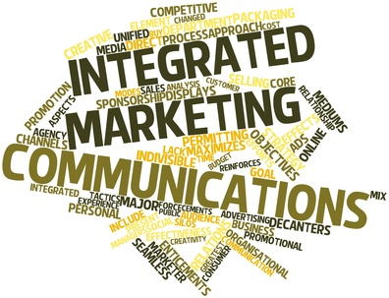
Optimizing integrated marketing should involve the use of push and pull marketing tactics that drive consumer behavior, REQ's Tripp Donnelly writes. "What people see in the physical world will drive their digital behavior," he notes.
Forbes 11/21/18
https://www.forbes.com/sites/forbesagencycouncil/2018/11/21/from-push-to-pull-and-back-again-integrated-marketing-in-the-digital-age/#4beb894c286b
Image credit:
http://brendanziolo.com/wp-content/uploads/2015/05/Integrated_marketing.jpg

