TAG Contributes to Reduction in Ad Fraud
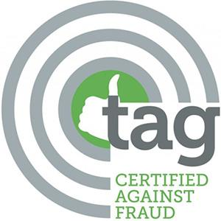
A 614 Group study revealed that 90% of the Trustworthy Accountability Group's more than 600 members claim a reduction in ad fraud and invalid rates falling from 1.48% in 2017 to a current 1.05%, which is well below the 10.83% industry average. Cybersecurity specialist CHEQ estimates ad fraud will cost businesses $35 billion during 2020, which would surpass $27 billion in credit card fraud and make it "the go-to medium for criminals," writes John Glenday.
The Drum (free registration) 11.5.20
https://www.thedrum.com/news/2020/11/05/fake-ad-traffic-dips-90-channels-signed-up-anti-fraud-project-says-tag
Image credit:

