Talking Money: World's Highest Paid TV Hosts
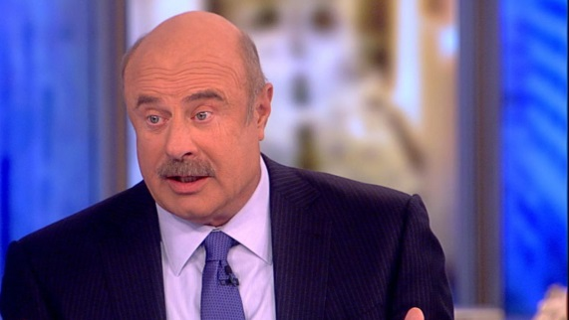
Combined, the world’s 10 highest-paid TV show hosts earned $462.5 million between June 1, 2016, and June 1, 2017, before management fees and taxes. Dr. Phil McGraw, Ellen DeGeneres and Ryan Seacrest lead the pack.
Forbes 11.8.17
https://www.forbes.com/sites/maddieberg/2017/11/07/the-worlds-highest-paid-tv-hosts-dr-phil-ellen-degeneres-and-ryan-seacrest-lead/#192f87f45bf6
Image credit:
http://abcnews.go.com/images/Entertainment/170202_view_drphil0.jpg

