Teen Smartphone Use to Outpace Overall Adult Use
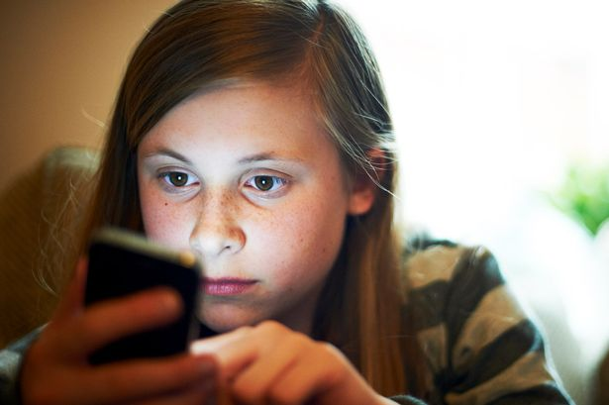
An eMarketer report forecasts that 78.9% of US 12- to 17-year-olds will be smartphone users this year. The figure is higher than the expected 77.1% of US adults who own smartphones, though millennials still have the highest smartphone penetration.
eMarketer 9/5/17
https://www.emarketer.com/Article/Understanding-Teens-Their-Smartphone-Habits/1016423
Image source:
http://i4.mirror.co.uk/incoming/article1811279.ece/ALTERNATES/s615/Young-Female-Using-Smart-Phone.jpg

