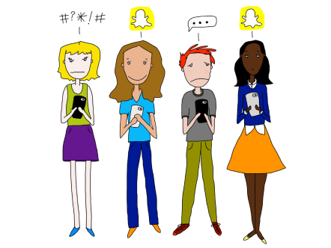
Teens’ Social Media Habits and Experiences
Teens credit social media for helping to build stronger friendships and exposing them to a more diverse world, but they express concern that these sites lead to drama and social pressure.
Pew Research 1.24.19
http://www.pewinternet.org/2018/11/28/teens-social-media-habits-and-experiences/?utm_source=Pew+Research+Center&utm_campaign=6ed82e6fde-Internet-Science_2018_09_20&utm_medium=email&utm_term=0_3e953b9b70-6ed82e6fde-399421641
Image credit:
https://cdn-images-1.medium.com/max/1200/0*Y-T5pTO5EgYpDj8q.

