Telemundo Shatters World Cup Records
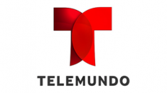
Telemundo snagged a surging 6.56 million viewers for the 8 a.m. PT-starting Group F match. The NBCUniversal-owned network saw its best Sunday daytime audience ever with the game, which marked the most watched group stage match ever on Spanish-language TV.
Deadline 6.19.18
https://deadline.com/2018/06/mexico-germany-telemundo-ratings-record-world-cup-1202412925/

