The Broadcast Upfronts by the Numbers
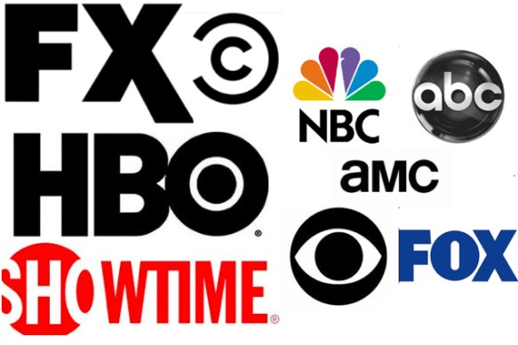
Broadcast upfront week is over, and soon media buyers and networks will begin the serious business of negotiating ad deals for next season. The upfront market usually breaks between now and the beginning of June, but before the deal-making begins, media buyers and planners need a few days to make sense of everything they saw last week.
MediaLife 5.20.16
http://www.medialifemagazine.com/the-broadcast-upfronts-by-the-numbers-2/

