The Case for More Sophisticated Use of Influencers
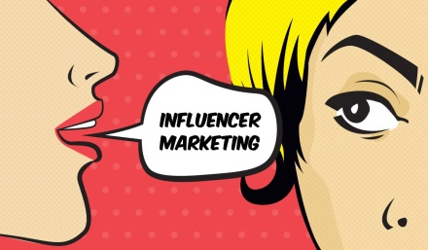
Forty-three percent of brands say they're experimenting with influencer marketing, with most investing less than $100,000 a year on the tactic, per Traackr and Top Rank Marketing. Marketers must recognize the importance of embedding word-of-mouth and influencer marketing across their companies and have an in-depth understanding of the buying journey to send the right influencer messaging at the right time, writes Wendy Marx.
Advertising Age 5/26/17
http://adage.com/article/digitalnext/influencer-marketer-grow/309146/
Image credit:
https://konacompany.com/wp-content/uploads/2016/12/influencer-marketing1.jpg

