The Cost of Apologizing for Facebook, Uber, Wells Fargo
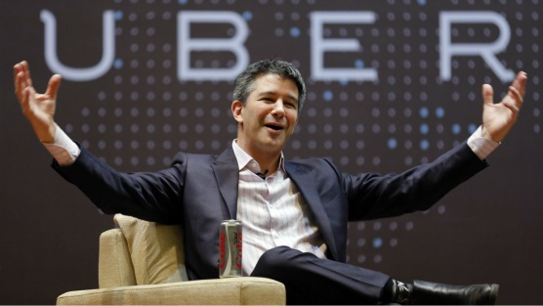
Uber, Wells Fargo and Facebook have all launched apologetic campaigns in recent months to try and win back consumer trust after various brand crises. Uber invested nearly $10 million in apology ads since May, Facebook has spent $30 million on TV ads and Wells Fargo has paid out close to $21.5 million, per iSpot.
The Drum (Scotland) 5/30/18
http://www.thedrum.com/news/2018/05/30/uber-and-facebook-are-learning-the-hard-way-saying-sorry-costly-business
Image credit:
http://techstory.in/wp-content/uploads/2017/03/travis-kalanick-fights-with-uber-driver.jpg

