The Deals That Changed the TV Industry This Decade
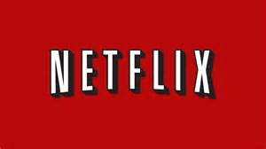
With the demand for content higher than ever before, it's been a boom time for many creatives in the industry. And that insatiable appetite for TV shows over the past decade has ushered in a handful of watershed deals, each of which has upended the business in its own way. With many led by pioneer Netflix — from the streaming giant's landmark House of Cards deal to its nine-figure Shonda Rhimes pact.
The Hollywood Reporter 12.27.19
https://www.hollywoodreporter.com/live-feed/deals-changed-tv-industry-decade-1263971?utm_source=Listrak&utm_medium=Email&utm_term=Deals+That+Changed+TV+In+This+Decade&utm_campaign=As+2019+Fades+To+Black%2c+We+Say+Goodbye

