The Factories In the Camps
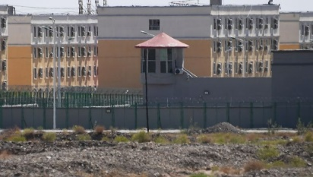
China has built more than 100 new facilities in Xinjiang where it can not only lock people up, but also force them to work in dedicated factory buildings right on site, BuzzFeed News can reveal based on government records, interviews, and hundreds of satellite images.
Pulitzer Center 12.28.21
https://pulitzercenter.org/reporting/factories-camps?utm_medium=Email&utm_source=newsletter&utm_campaign=20210105
Image credit:
https://images.foxtv.com/static.fox29.com/www.fox29.com/content/uploads/2019/11/764/432/GETTY_chinese_detention_camps.jpg?ve=1&tl=1

