The Future of Late-Night TV is Online
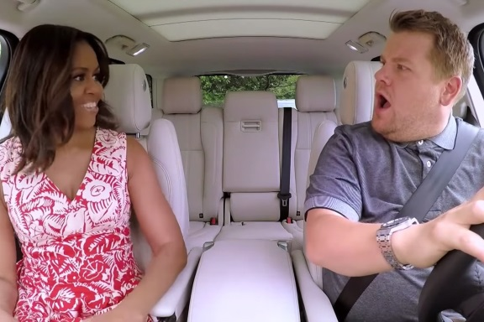
CBS “Late Late Show” host James Corden is an afterthought in the Nielsen ratings, ranking third in its timeslot in viewers. But he’s a rock star online. Earlier this year, his “Carpool Karaoke,” a recurring skit in which Corden ferries a famous person around in his car while they sing to new and old hits on the radio, surpassed 1 billion views online.
MediaLife 10.5.16
http://www.medialifemagazine.com/readers-future-late-night-tv-online/

