The Future of News is On Demand
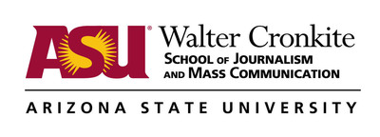
The rise in on-demand and “OTT” viewing as the most direct threat to traditional live linear viewing. Here are five critical things TV news leaders and executives need to understand and respond to now to insure their content remains relevant in this new, disrupted viewing ecosystem.
Knight-Cronkite News Lab 12.21.18
https://cronkitenewslab.com/management/2018/12/21/the-future-of-broadcast-news-is-ott-on-demand/?utm_source=Listrak&utm_medium=Email&utm_term=The+Future+Of+News+Is+On+Demand&utm_campaign=Nexstar%27s+Sook+Stays+Focused+On+The+Local

