The Impressive Resilience of Digital Audio
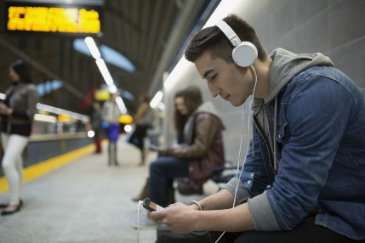
Listeners developed new habits and preferences while working and schooling from home. Apps like Spotify and Pandora reported increased usage via smart speakers and smart TVs, and increased usage at unusual times of day; for instance, weekday usage began to resemble weekend usage. Podcasts, too, reportedly saw an unexpected spike in popularity, as long-form audio engagement became easier to undertake at any given time of day.
eMarketer 2.16.21
https://www.emarketer.com/content/impressive-resilience-of-digital-audio?ecid=NL1001
Image credit:
https://www.lifewire.com/thmb/Aw7konfZ8Gudmc6w1w_mYbZa7r0=/768x0/filters:no_upscale():max_bytes(150000):strip_icc()/GettyImages-638688589-5b8d671846e0fb002531e77e.jpg

