The Internet of Things, Commercialized
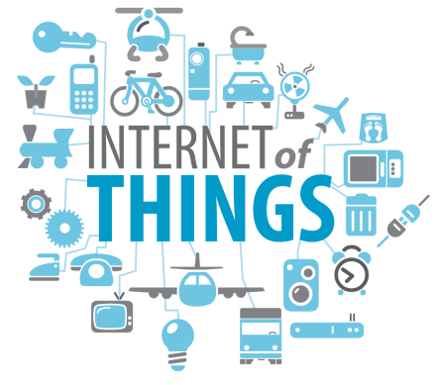
Imagine a bottle of whisky that can not only tell you, through a smart label that communicates with your smartphone, if it’s been opened or not, but can also offer serving suggestions and let you upload a video that can be played by the person you’re buying the whisky for. Actually, you don’t have to imagine.
MediaLife 9.3.15
http://www.medialifemagazine.com/the-internet-of-things-commercialized/

