The Most Social TV Shows Of 2016
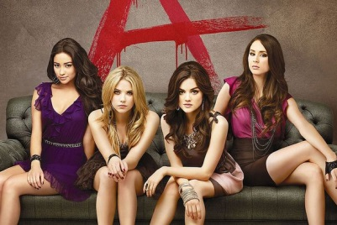
For truly rabid social fans, nothing on television came close to #PLL this past year. Freeform’s Pretty Little Liars far and away was the No. 1 show in terms of overall social engagement across major platforms, according to an analysis by research firm ListenFirst Media for Jan. 1 to Dec. 15, 2016. In fact, engagement for the show increased 25% versus the same period in 2015, to register more than 256 million interactions for 2016.
Variety 12.21.16
http://variety.com/2016/tv/news/2016-most-social-tv-shows-1201946167/

