The Power of Stories: Words That Make People Listen, Care and Act
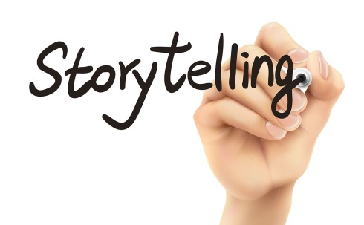
Telling stories is one of the oldest art forms, used by every culture to share experiences, record history, convey values and teach lessons. Remember those story problems from grade-school math class? Stories convey information in ways that people remember and respond to more than when the same information is delivered in non-narrative forms.
Strategies & Tactics 2.4.19
http://apps.prsa.org/StrategiesTactics/Articles/view/12450/1166/The_Power_of_Stories_Words_That_Make_People_Listen#.XGqzfE_2Y5h
Image credit:
https://destinonegocio.com/wp-content/uploads/2015/11/ico-destinonegocio-storytelling-istock-getty-images.jpg

